## INDEX

Title and Abstract 1

Platforms and Tools 2

Diagrams supporting the Project 4

Screenshots 10

Conclusion 11

Bibliography and References 12

## Title and Abstract

**Title:** Health Center Website

**Abstract:**

To build a prototype of website for PhysioYoga health center, The website let the user know the products and services offered. Moreover, the website also let user purchase a product or service by paying online directly.

The aim is to build a robust website which provides a management service to the health center and also let the administrators manage and add different products and services. The website offers an online payment service after a successful account creation. The website leads to a potential customer and promotes the health center online.

## Platforms and Tools

For building the website we have used MERN stack which is an industry standard. MERN stands for MongoDB, Express, React, Node, after the four key technologies that make up the stack.

* MongoDB - document database
* Express(.js) - Node.js web framework
* React(.js) - a client-side JavaScript framework
* Node(.js) - the premier JavaScript web server

**JavaScript:**

Object-oriented programming language used for scripting the webpages and backend

**React JS:**

JavaScript framework for creating dynamic client-side applications in HTML. React lets you build up complex interfaces through simple Components, connect them to data on your backend server, and render them as HTML.

**Bootstrap:**

Bootstrap is a free and open source front end development framework for the creation of websites and web apps. The Bootstrap framework is built on HTML, CSS, and JavaScript (JS) to facilitate the development of responsive, mobile-first sites and apps.

**NodeJS and ExpressJS:**

The next level down is the Express.js server-side framework, running inside a Node.js server. Express.js bills itself as a “fast, unopinionated, minimalist web framework for Node.js,” and that is indeed exactly what it is. Express.js has powerful models for URL routing (matching an incoming URL with a server function), and handling HTTP requests and responses.

**MongoDB:**

MongoDB is a scalable, open source, high performance, document-oriented database. It is an open-source document database that provides high performance, high availability, and automatic scaling.

**Hostinger:**

Hostinger is a versatile web host that offers excellent uptime and customer service, as well as a mix of traditional and cloud-based hosting.

**Stripe:**

Stripe is a payment processor, it allows business owners to accept payments from credit and debit cards and processes those payments.

**Adobe XD**

It is a vector-based user experience design tool for web apps and mobile apps, developed and published by Adobe Inc. Adobe XD enables website wireframing and creating click-through prototypes

## Diagrams supporting the Project

**Use Case diagram**

A use case diagram is a graphical depiction of a user's possible interactions with a system. A use case diagram shows various use cases and different types of users the system has.

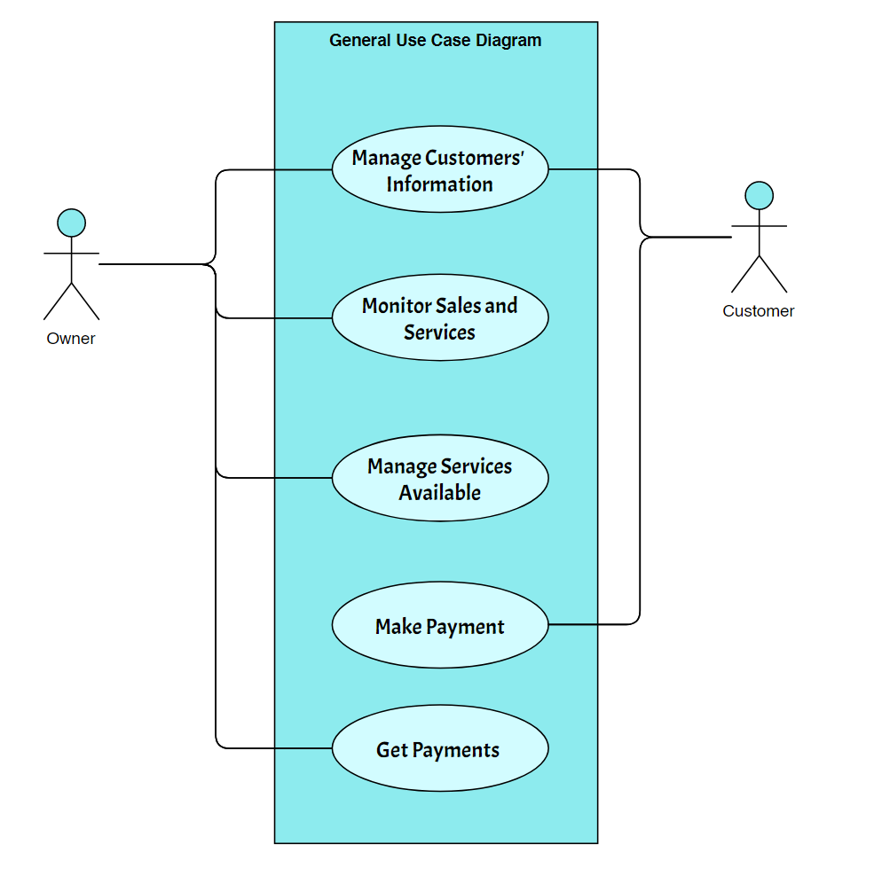

**Sequence Diagram**

Sequence diagrams are a popular dynamic modeling solution because they specifically focus on lifelines, or the processes and objects that live simultaneously, and the messages exchanged between them to perform a function before the lifeline ends.

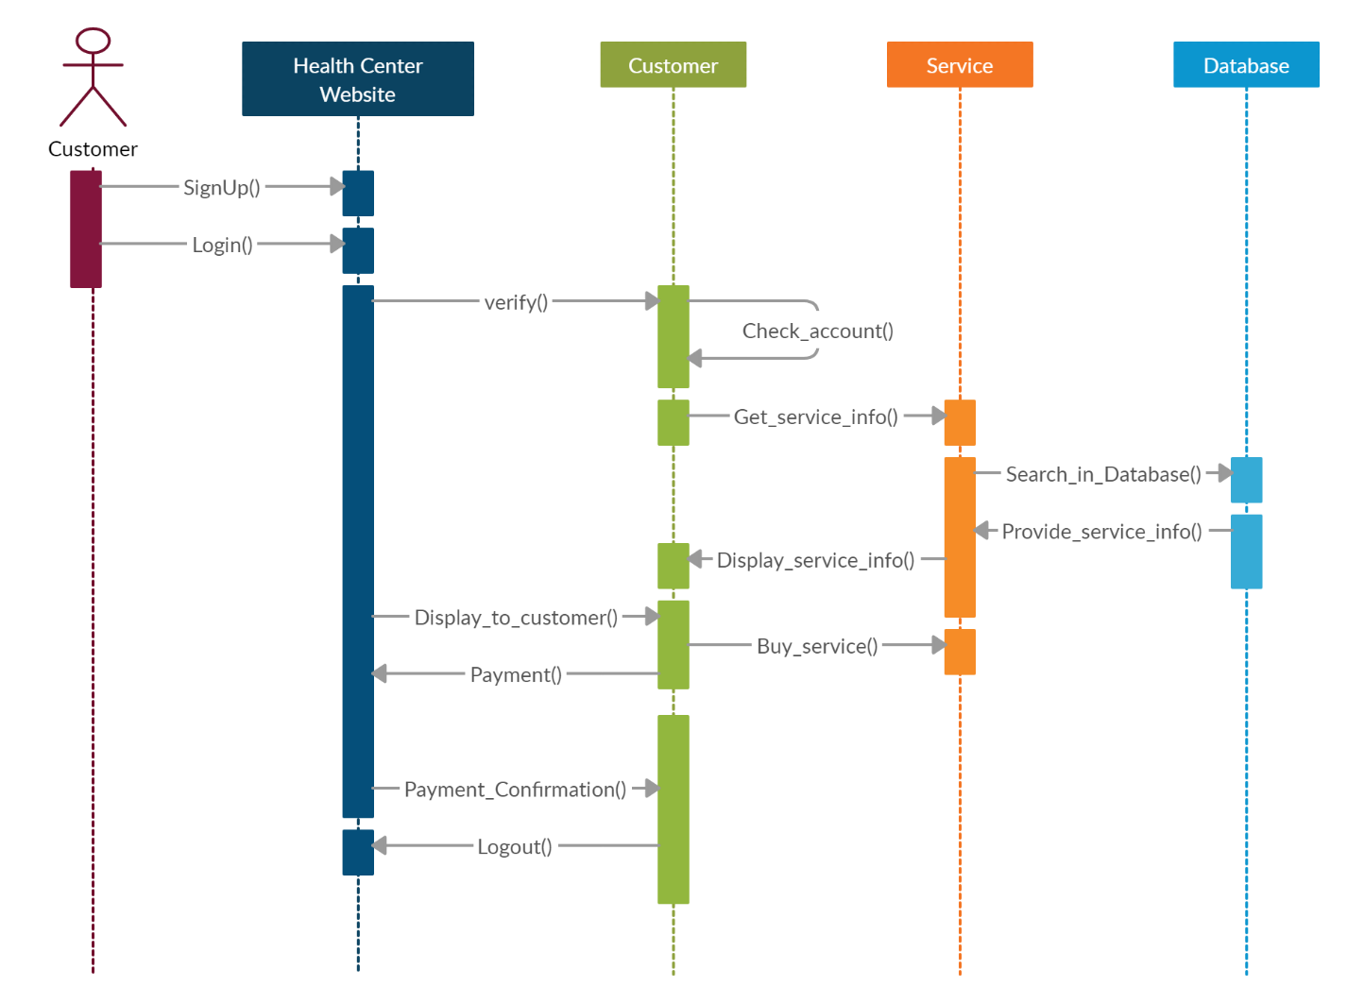

**Activity Diagram**

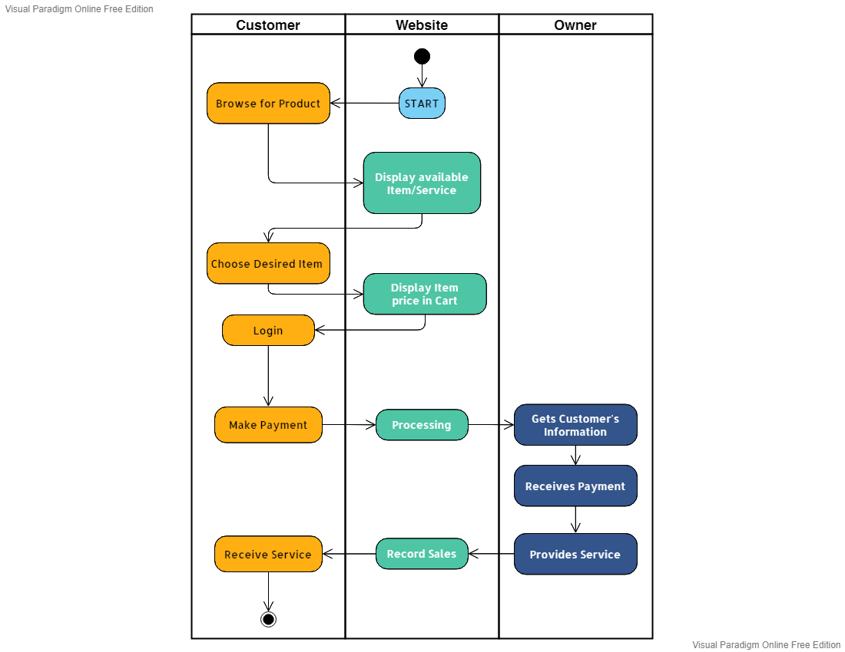Activity diagram is basically a flowchart to represent the flow from one activity to another activity. The activity can be described as an operation of the system. The control flow is drawn from one operation to another. This flow can be sequential, branched, or concurrent. Activity diagrams deal with all type of flow control by using different elements. Here the human point of contact is the receptionist who manages the availability of the Service provides and assigns clients to them. It used to show a high level of implementation only

**Data Flow Diagram**

A data-flow diagram is a way of representing a flow of data through a process or a system (usually an information system). The DFD also provides information about the outputs and inputs of each entity and the process itself. A data-flow diagram has no control flow — there are no decision rules and no loops.

99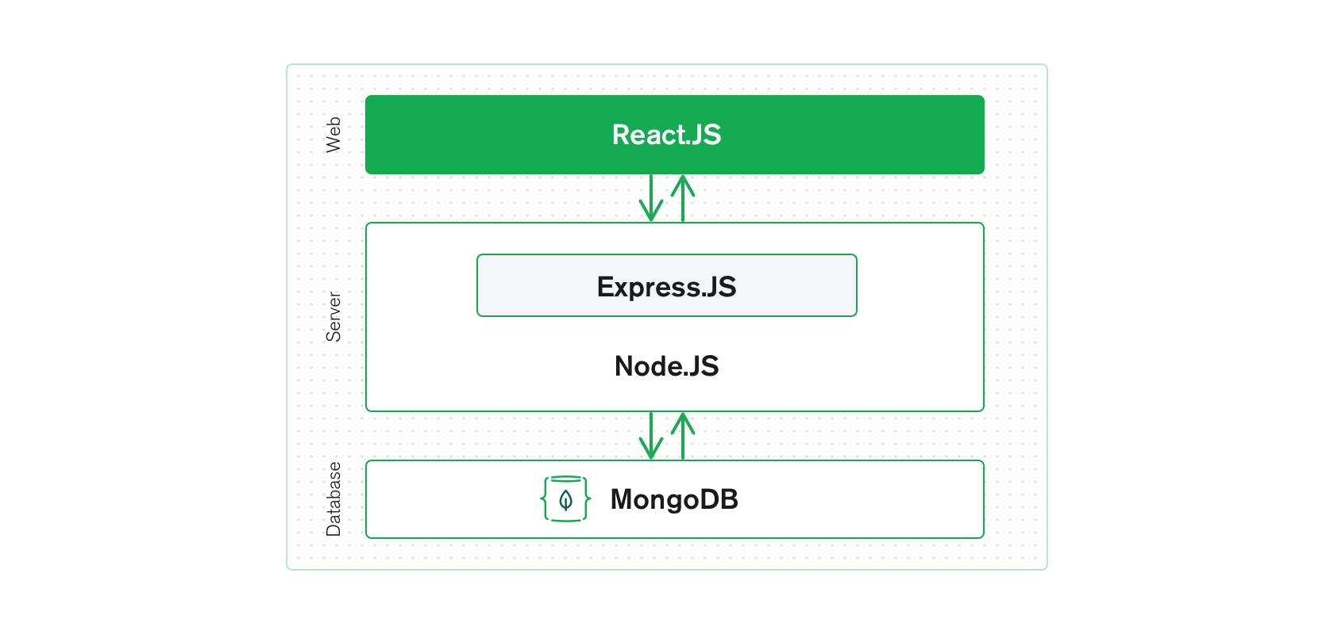

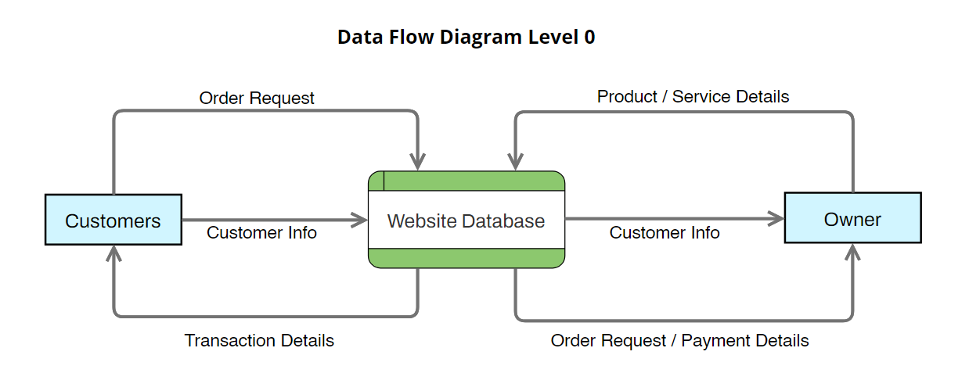

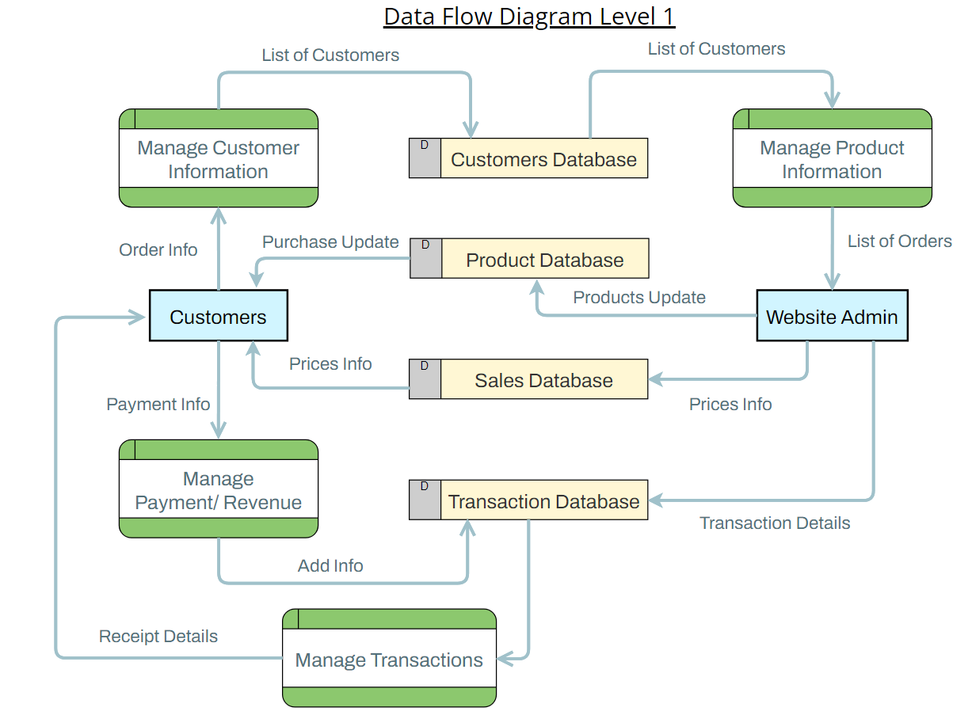

**Data dictionary**

A Data Dictionary is a collection of names, definitions, and attributes about data elements that are being used or captured in a database. When developing programs that use the data model, a data dictionary can be consulted to understand where a data item fits in the structure, what values it may contain and what the data item means in real-world terms.

## Screenshots

## Conclusion

## Bibliography and References

**Websites:**

Diagrams and Flow Charts are generated using <https://online.visual-paradigm.com/>

About JavaScript; <https://developer.mozilla.org/en-US/docs/Web/JavaScript>

React Documentation <https://reactjs.org/docs/getting-started.html>

MongoDB documentation <https://www.mongodb.com/docs/>

Elements of website <https://www.freepik.com/> ; <https://www.pexels.com/>

About Mailchimp: Landing Page: <https://eepurl.com/dyilab>

About MERN stack: <https://www.mongodb.com/mern-stack>

UML Sequence Diagrams: <https://www.geeksforgeeks.org/unified-modeling-language-uml-sequence-diagrams/>

**Published Papers and White Papers**

Halili, Festim & Rustemi, Avni. (2016). MODELING OF AN E-BUSINESS SYSTEM. INTERNATIONAL JOURNAL OF COMPUTERS & TECHNOLOGY. 15. 7308-7315. 10.24297/ijct.v15i12.3969.

Ciccozzi, F., Malavolta, I. & Selic, B. Execution of UML models: a systematic review of research and practice. Softw Syst Model 18, 2313–2360 (2019). doi.org/10.1007/s10270-018-0675-4